**Swofantasygolf Admin Instructions**

**Required Software/Accounts:**

* Microsoft Access (most versions should work. Not tested on all versions)
* Microsoft Excel (most versions should work. Not tested on all versions)
* GitHub Desktop (Requires account on GitHub before downloading)

**Getting Started.**

**Github user account:** [**https://github.com/join**](https://github.com/join)

* Follow instructions to get github account

**Github Desktop:** [**https://desktop.github.com/**](https://desktop.github.com/)

* Download and install latest github desktop client.

The current administrator will need to provide you contributor access and/or transfer ownership of the site to your github account.

**GitHub Repository**

# [SWOFantasyGolf](https://github.com/SWOFantasyGolf)/[SWOFantasyGolf.github.io](https://github.com/SWOFantasyGolf/SWOFantasyGolf.github.io)

**Microsoft Access Database**

FantasyGolf.mdb – Included in download from repository

**Microsoft Excel**

Index.html – included in download from repository (Open in Excel)

**Setting Up Base Database Tables (This is required before starting up a new year)**

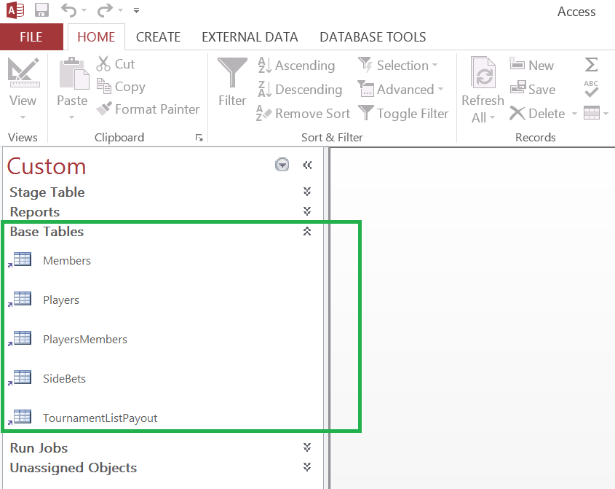

The base tables are in the Navigation Group called “Base Tables” in the MS Access Program. These tables are normally only required to be updated once a year at the beginning of the season. There are 5 base tables:

**Members**: - Used to put in the fantasy golf participant/teams names, pick order, email address. It also auto assigns a unique key number (ID) used for program jobs and reports.

**Players**: - Used to put in the PGA player names that will be used to match up when loading results from pgatour.com. It also auto assigns a unique key number (ID) used for program jobs and reports.

**PlayersMembers**: Used to assign a member to players and assigned the pick order number.

**SideBets**: Used to assign side bets between players.

**TournamentListPayout**: Used to assign payout amount and schedule for the fantasy golf year.

**Quick Instructions for Loading weekly tournaments**